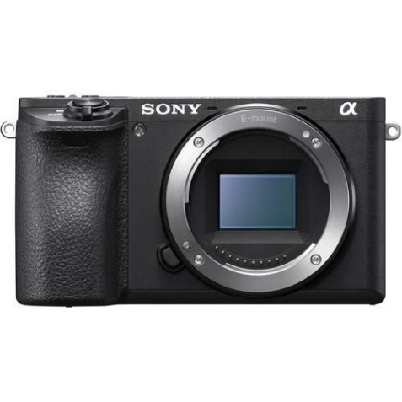



Sony Alpha A6500 Mirrorless Digital Camera (Body Only)

₨.128,000
Description:

Sony Alpha a6500 Mirrorless Digital Camera (Body Only) Price & Specs

Sony Alpha A6500 Mirrorless Camera Price in Pakistan has seen many ups and downs, but no matter the price, this camera is surely worth buying. It is a versatile shooter that is made for photography and film making. A6500 comes with a 24.2 MP CMOS sensor for quality output. Capable of shooting at 4k, 1080p, and more on designated settings. The processing speed is fast and comes with a 4D focus. A6500 also has high-density tracking AF to help you focus on your subject.

The camera can also capture 11 FPS and has 425 phase-detect points. It comes with in-build image stabilization and various color profiles. The standout features include slow & quick motion, Wi-Fi, Zebra & Gamma display, Smooth touch screen, sleek body design, time code, and various customize able settings. If you want a one-time solution for your studio or looking to upgrade to a more professional camera, then Sony Alpha is definitely the one to go for.

24.2MP APS-C Exmor CMOS Sensor

BIONZ X Image Processor

XGA Tru-Finder 2.36m-Dot OLED EVF

3.0" 921.6k-Dot Tilting Touchscreen LCD

Internal UHD 4K Video & S-Log3 Gamma

S&Q Motion in Full HD from 1-120 fps

5-Axis SteadyShot INSIDE Stabilization

Built-In Wi-Fi with NFC

4D FOCUS with 425 Phase-Detect Points

Up to 11 fps Shooting and ISO 51200

DESCRIPTION:

Stable, fast, and versatile, the Alpha a6500 from Sony is an apt APS-C-format mirrorless camera well-suited for both photo and video applications. Revolving around a 24.2MP Exmor CMOS sensor and BIONZ X image processor, clean image quality is provided with a wide expandable sensitivity range to ISO 51200, along with accelerated readout speeds for internal 4K30 and Full HD 1080p120 video recording with full pixel readout. The processor further benefits videographers with the inclusion of an S&Q (Slow & Quick) Motion setting that permits capturing Full HD video at a variety of frame rates ranging from 1-120 fps. Stills shooters also benefit from the apt processing speed, which enables continuous shooting at 11 fps for up to 301 JPEGs in a burst, as well as 14-bit raw file output. Complementing both stills and video, 5-axis SteadyShot INSIDE image stabilization minimizes the appearance of camera shake with all mounted lenses to support working with slower shutter speeds. The sensor and processor combination also avails 4D FOCUS, which utilizes a wide-coverage 425-point phase-detection system with a 169-area contrast detection system for quick and precise focusing performance. This focusing system also enables High-density Tracking AF for more efficient and accurate tracking of moving subjects across the image frame. Increasingly versatile and fully featured in both photo and video realms, the a6500 is a fast and precise imaging tool for multimedia capture.

Complementing the imaging assets, the a6500 also sports a robust magnesium alloy body that is dust- and moisture-resistant to permit working in harsh environments. The compact profile incorporates a high-resolution XGA Tru-Finder 2.36m-dot OLED electronic viewfinder for bright, clear, eye-level viewing, and this EVF features a 120 fps viewing mode for smooth tracking of fast-moving subjects. A rear 3.0" 921.6k-dot touchscreen LCD monitor is also available and has a tilting design to benefit shooting from high and low working angles, and the touchscreen design allows for intuitive touch-to-focus control. Additionally, for wireless remote control over the camera, or for just sharing imagery online, built-in Wi-Fi with NFC permits linking with a mobile device for intuitive wireless control.

24.2MP Exmor CMOS Sensor and BIONZ X Processor

The APS-C-format 24.2MP Exmor CMOS sensor pairs with the BIONZ X image processor to realize smooth, nuanced image quality with minimal noise and high sensitivity from ISO 100-25600, which can further be expanded to ISO 51200 for working in low-light conditions. The sensor features a unique design that utilizes thin copper wiring, enhanced circuit processing, and an enhanced front-end LSI to boost light-gathering abilities, reduce noise, and increase readout speeds to benefit video recording. The sensor and processor combination also avails a top continuous shooting rate of 11 fps for up to 301 standard JPEG frames or 107 raw frames in a single burst with AF and AE, and permits 14-bit raw file output for a wider tonal and color scale.

5-Axis SteadyShot INSIDE Image Stabilization

Packed into the svelte a6500 is a 5-stop effective 5-axis SteadyShot INSIDE image stabilization system that compensates for five different types of camera shake encountered during handheld shooting of stills and video. This allows users to confidently use any lens, even adapted lenses, for critical imaging without encountering blur from camera shake.

For long focal lengths, the system will correct for pitch and yaw adjustments. Macro and high-magnification imagery, on the other hand, will benefit from the inclusion of horizontal and vertical shift compensation. All shooting styles will get usage out of the roll compensation. All 5 axes of stabilization will function at all times, even when used with third-party lenses and adapters or lenses with built-in optical stabilization.

4D FOCUS

Covering nearly the entire sensor area, a powerful 4D FOCUS system incorporates 425 on-chip phase-detection points along with 169 contrast-detection areas for precise focusing in as little as 0.05 seconds. The density of focusing points from this hybrid AF system also enables High-density Tracking AF Technology, which is adept at tracking moving subjects in a variety of lighting conditions. The use of phase-detection points also enables the use of A-mount lenses via the optional LA-EA3 or LA-EA1 lens mount adapters with full AF compatibility.

The apt 4D FOCUS system also lends itself to a variety of focusing functions for refined accuracy, including Lock-on AF, which maintains focus on moving subjects throughout the use of a configurable frame that is set over the desired moving subject, and Expand Flexible Spot, which employs neighboring focus points to retain focus on moving subjects even if the originally selected point loses focus. Additionally, Eye AF can be used to base focus on recognized subjects' eyes for portraits and is available in both AF-S and AF-C modes. Autofocus can also be used in conjunction with the Focus Magnifier function for critical focus when homing in on minute subject details.

In addition to autofocus, the a6500 also features a Peaking MF function to benefit manual focus control by highlighted sharp edges of contrast for a more objective means of acquiring sharp focus.

UHD 4K Video Recording

Internal recording of UHD 4K movies is possible in multiple frame rates up to 30 fps and, based on the Super35mm recording area and effective 20MP (6000 x 3376) resolution, 2.4x oversampling renders greater detail and full pixel readout is possible, that is void of pixel binning, for higher quality imagery with reduced moiré and aliasing. Full HD 1080p recording is also supported in frame rates up to 120 fps, and both resolutions utilize the 100 Mbps XAVC S format contained within an MP4 wrapper with 4:2:0 sampling. The high-speed, 120 fps recording also enables 4x and 5x slow-motion movie recording with the frame rate set to either 30p or 24p. In addition to high-resolution internal recording, uncompressed HDMI output also enables the use of an optional external recorder for clean 4K recording with 4:2:2 sampling.

4K video recording also avails the ability to produce 8MP stills during playback by taking a frame grab from a movie and storing it as a separate file.

Custom Color Profiles and S-Log3 Gamma

Support is available for the S-Gamut3.Cine/S-Log-3 and S-Gamut3/S-Log3 profiles that enable up to a 1300% wider dynamic range for smoother tonal and color gradations, along with enhanced sensitivity and clarity in shadows and mid-tones. These profiles also lend themselves to greater compatibility within a professional workflow and are well-paired to the Cineon Log gamma curve for versatile post-production grading and color control. The S-Log3 gamma setting also offers an impressive 14-stop wide dynamic range for greater control over the highlights and shadows, while the S-Gamut3.Cine profile can be used to mimic the qualities of scanned negative film with a wide gamut comparable to the DCI-P3 color space. Additionally, the popular S-Log2 setting is also available.

Slow & Quick Motion

Take more control over your video capture capabilities with a variety of new frame rates available in an S&Q mode. This will allow shooters to capture Full HD video at one of either steps between 1-120 fps. These settings will allow you to slow down action as well as speed up a slow moving scene. This setting is also NTSC/PAL switchable.

Zebra and Gamma Display Assist

An enhanced Zebra function is ideally suited to working with S-Log gamma profiles and aids in monitoring exposure values in high-contrast scenes. Video signal level targets can be set from 0 to 109, and specific ranges can be set to make exposure level adjustments easier.

In contrast, a Gamma Display Assist function is also available that displays scenes with natural contrast when recording with S-Log settings. This function converts imagery to the ITU709 profile for easier on-camera monitoring.

Time Code and User Bit Settings

A time code can be used to record hours, minutes, seconds, frames on image data for more precise editing while the User Bit function can record date, time, and scene number to aid in editing together footage from multiple cameras.

Body Design and Built-In Wi-Fi

A robust magnesium alloy body offers a durable profile, and also incorporates dust and moisture seals to protect against harsh environments. This durability is carried over to the shutter's design, too, which is rated to withstand more than 200,000 cycles.

The XGA Tru-Finder 2.36m-dot OLED electronic viewfinder offers a bright, high-resolution means for eye-level monitoring, and also sports a dedicated 120 fps mode for smoother viewing when tracking moving subjects.

A 3.0" 921.6k-dot LCD touchscreen can be tilted 90° upward or 45° downward to suit working from high and low angles. The screen also incorporates White Magic technology with an RGBW pixel structure for increased brightness to support use in daylight conditions.

The touchscreen design avails access to Touch Focus control, for immediate focus point selection, as well as a Touchpad function which lets you smoothly and intuitively select a focus point on the screen while you're looking into the viewfinder.

Nine customizable buttons can be set to control more than 64 functions for more intuitive handling.

The included NP-FW50 rechargeable lithium-ion is rated for 350 shots per charge when working with the viewfinder, or 400 shots per charge with the LCD screen.

In addition to the battery, the a6500 can also be powered via a USB connection to a computer or mobile battery. This connection can also be used to charge the battery.

A rigid metal lens mount better supports working with larger, heavier lens designs.

An ergonomic grip structure is ideal for long shooting sessions and facilitates easy access to the main control buttons and dials.

Built-in Wi-Fi enables the a6500 to instantly share imagery to mobile devices for direct sharing online to social networking, via email, and to cloud storage sites. NFC (Near Field Communication) is also supported, which allows for one-touch connection between the camera and compatible mobile devices; no complex set-up is required. Once connected, the linked mobile device can also display a live view image on its screen and remotely control the camera's shutter.

Bluetooth connectivity allows for location data acquisition.

PlayMemories Camera Apps are also supported via the built-in Wi-Fi connection, and allow you to personalize the camera's features depending on specific shooting styles. Apps are available to suit creating portraits, detailed close-ups, sports, time lapse, motion shot, and other specific types of imagery.

Other Camera Features

Highlight and Average metering modes helps avoid blown-out highlights and provide stable auto exposure, respectively.

Exposure standard adjustment allows you to tween exposure parameters for each metering mode independently from -1 to +1 EV in 1/6-stop increments.

A Silent Shooting mode makes use of an electronic shutter function for completely silent performance that is ideal for photographing in noise-sensitive areas. When using this mode, up to 3 fps continuous shooting is available with autofocus and auto-exposure.

Multi Frame NR records consecutive images at a reduced ISO sensitivity and then composites them into a single image to realize higher effective sensitivity with minimal image noise.

Dynamic Range Optimizer (DRO) works to improve images featuring backlit subjects or scenes with high contrast where details can be lost in the shadows or highlights. This mode can be controlled automatically or fine-tuned using five settings.

Auto HDR automatically records three sequential frames of an image and composites them into a single frame to realize greater shadow and highlight detail with an extended range of mid-tones.

An advanced 1200-zone evaluative exposure metering sensor delivers consistent and accurate results using multi-segment, center-weighted, or spot metering modes.

When working with ISO Auto settings, you can configure a minimum shutter speed setting to better ensure sharp imagery.

Clear Image Zoom can be used to magnify the center of scenes by 2x to effectively extend the reach of any focal length lens. This digital zoom technology uses an intelligent interpolation process to minimize the amount of image degradation in order to produce realistic, high-quality images.

Picture Effect: Posterization (Color, B/W), Pop Color, Retro Photo, Partial Color (R, G, B, Y), High Contrast Monochrome, Toy Camera, Soft High-key, Soft Focus, HDR Painting, Rich-tone Monochrome, Miniature, Watercolor, and Illustration.

Creative Style: Standard, Vivid, Neutral, Clear, Deep, Light, Portrait, Landscape, Sunset, Night Scene, Autumn Leaves, Black & White, and Sepia; contrast, saturation, and sharpness can be adjusted across +/- 3 steps.

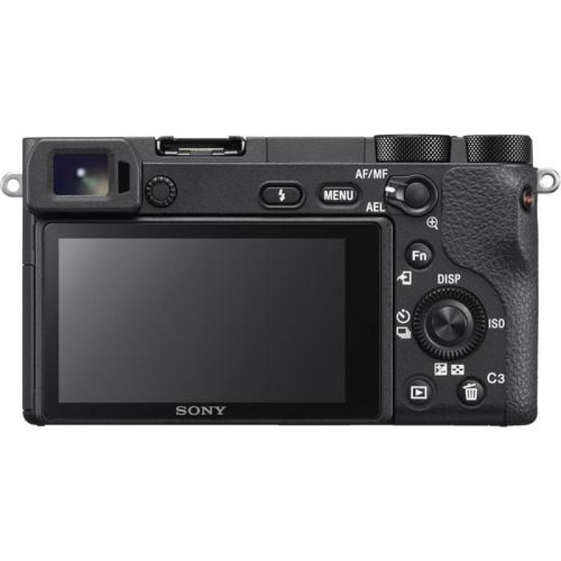
Pictures:
